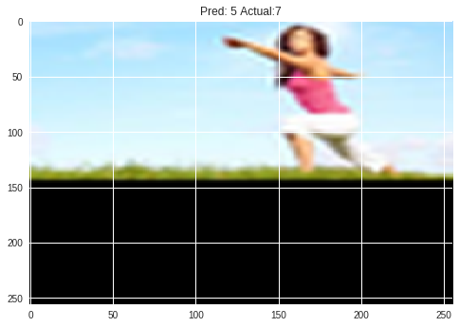

-------------------------------------------------------------------

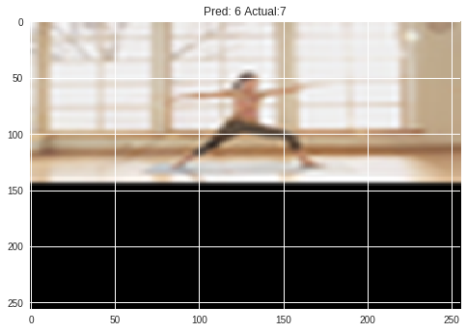

-------------------------------------------------------------------

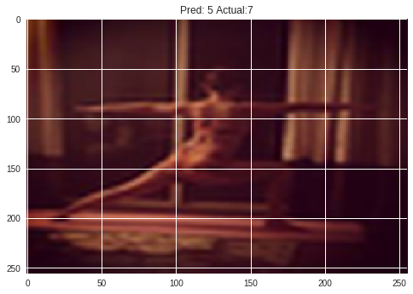

-------------------------------------------------------------------

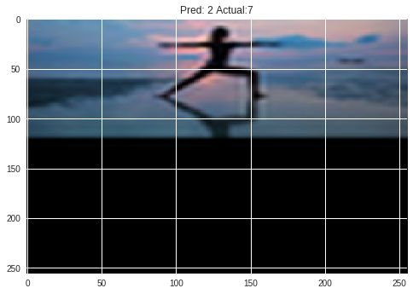

-------------------------------------------------------------------

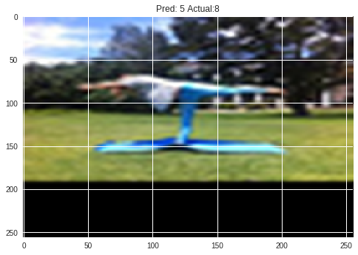

-------------------------------------------------------------------

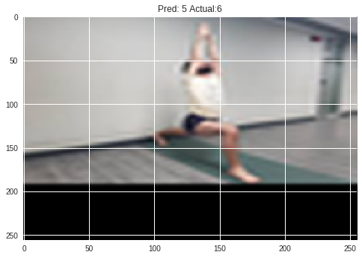

-------------------------------------------------------------------

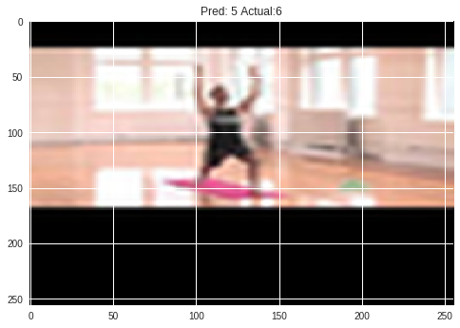

-------------------------------------------------------------------

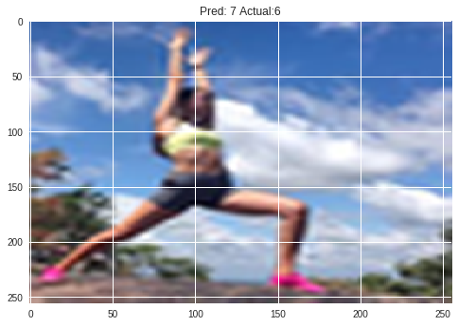

-------------------------------------------------------------------

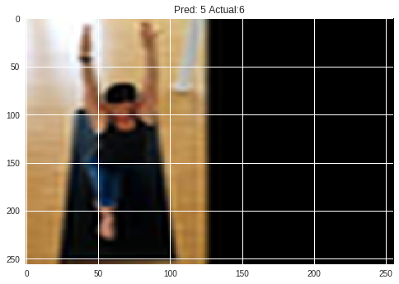

-------------------------------------------------------------------

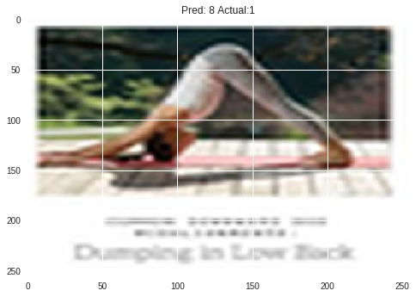

-------------------------------------------------------------------

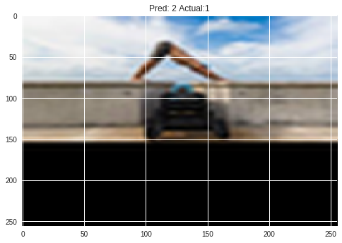

-------------------------------------------------------------------

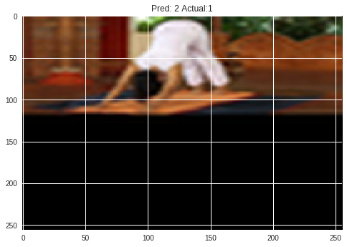

-------------------------------------------------------------------

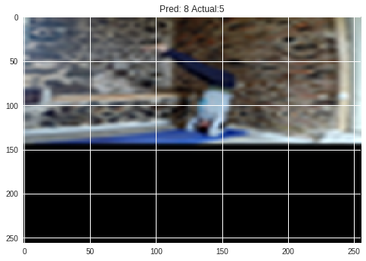

-------------------------------------------------------------------

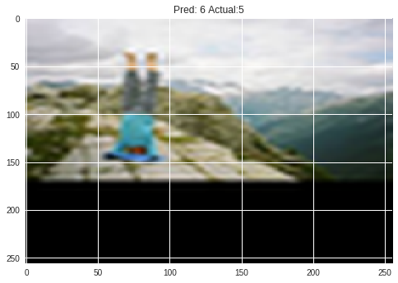

-------------------------------------------------------------------

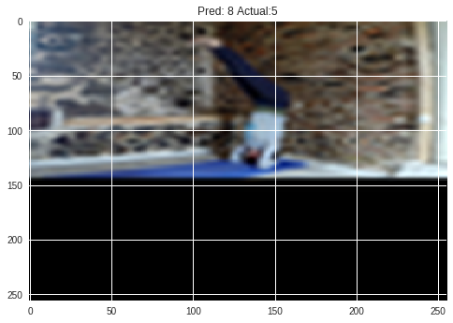

-------------------------------------------------------------------

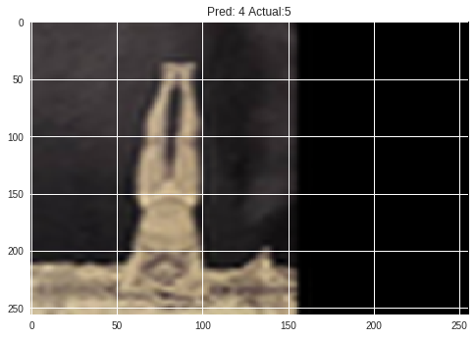

-------------------------------------------------------------------

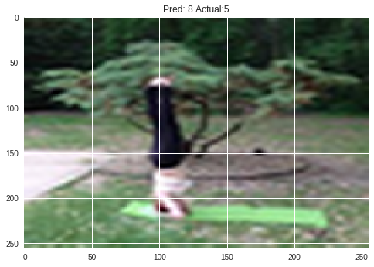

-------------------------------------------------------------------

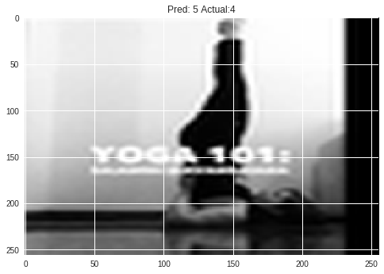

-------------------------------------------------------------------

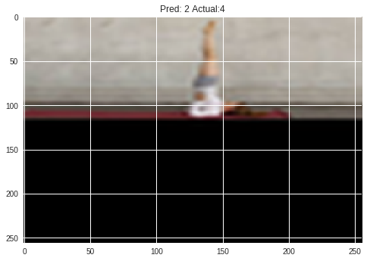

-------------------------------------------------------------------

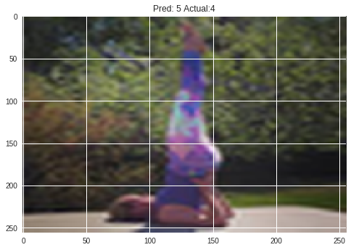

-------------------------------------------------------------------

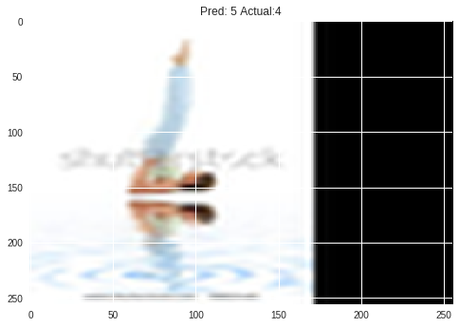

-------------------------------------------------------------------

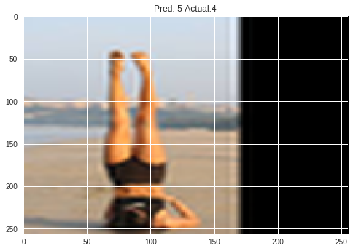

-------------------------------------------------------------------

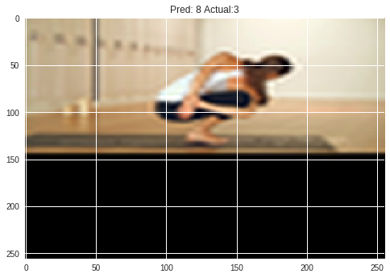

-------------------------------------------------------------------

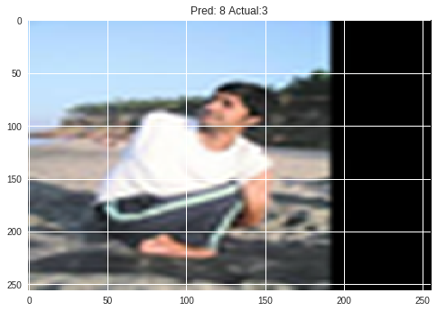

-------------------------------------------------------------------

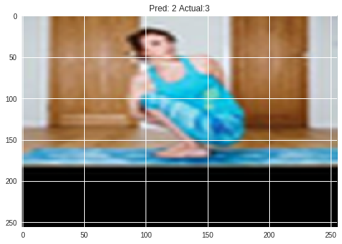

-------------------------------------------------------------------

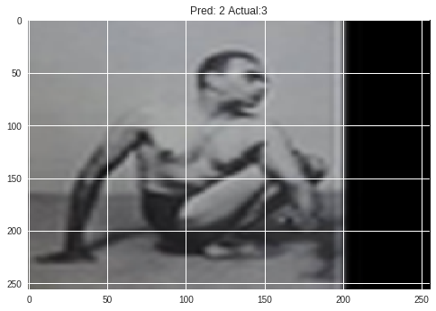

-------------------------------------------------------------------

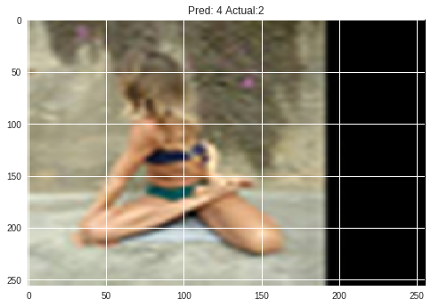

-------------------------------------------------------------------

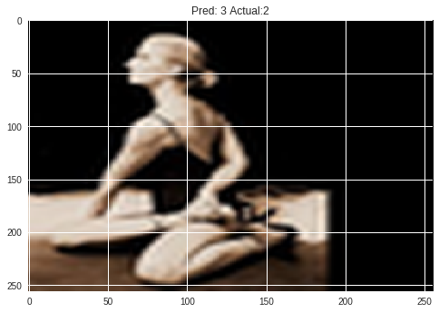

-------------------------------------------------------------------

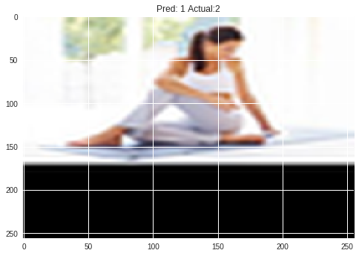

-------------------------------------------------------------------

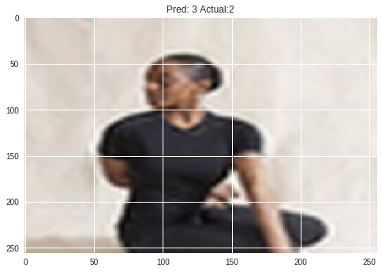

-------------------------------------------------------------------

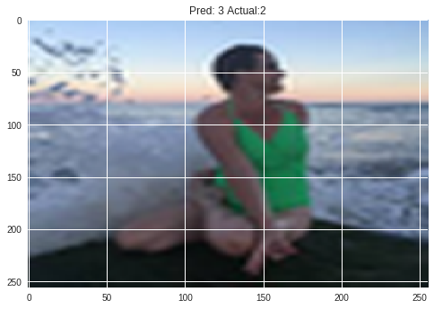

-------------------------------------------------------------------

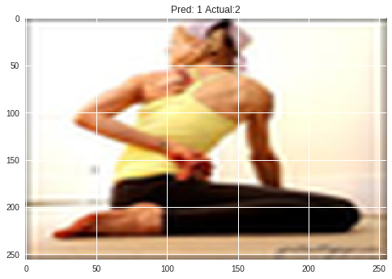

-------------------------------------------------------------------

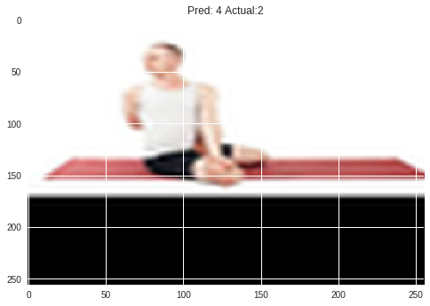

-------------------------------------------------------------------

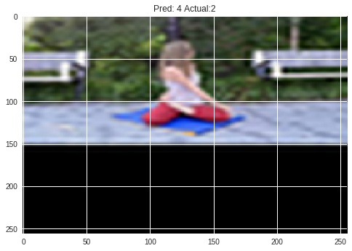

-------------------------------------------------------------------

Summary :

Average Prediction Accuracy :0.8716981132075472

Total Correct :231

Total Misclassifications :34

Total Prediction Time :2.746964454650879

Confusion matrix, without normalization

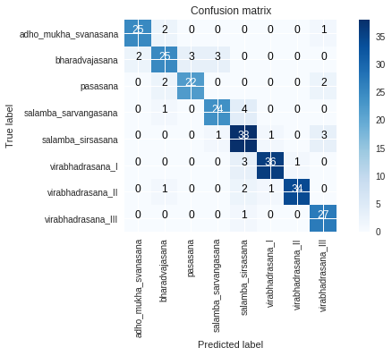

Normalized confusion matrix

